Chapter No. 01
Library Management System Project
  - About the Project
Library Management system is software used to manages the catalog of a library. This helps to keep the records of whole transactions of the books available in the library.
Library Management System is very easy to use and fulfills all the requirement of a librarian. A college library management is a project that manages and stores book information electronically according to student’s needs. The system helps both students and library manager to keep a constant track of all the books available in the library. It allows both the admin and the student and search for the desired book. It becomes necessary for college to keep a continuous check on the books issued and returned and even calculate fine. This task if carried out manually will be tedious and includes chances of mistakes. These errors are avoided by allowing the system to keep track of information such as issue date, last date to return the book and even fine information and thus there is no need to keep manual track of this information which thereby avoids chances of mistakes.
Thus this system reduces manual work a great extent allows smooth flow of library activities by removing chances of errors in the details.
1.2 Advantages
- The system excludes the use of paper work by managing all the information electronically.
- Admin can keep updating the system by providing the new books arrival in system and their availability thus students need not to go to library for issuing purpose.
- The system has books well organized and systematically arranged in different categories in the system so that user can easily search and find the book.
- Thus it saves human efforts and resources.
1.3 Disadvantages
- There is no Human interaction if users have some enquiry.

1.4 Objectives of library Management System (LMS)
- TO build a system that can receive input and generate automatically output in easy way and short time.
- To build a monitoring system that is able to monitor and manage all library operations efficiently.
- Give an opportunity to librarians to reduce mistakes that always happen during manual method.
- To store properly the library items in order to maintain their security.
- To enter and preserve details of the various issues and keep a track on their returns.
1.5 Features of Library Management System
- Keep record of different categories like; Books, Journals, Newspapers, Magazines, etc.
- Classify the books subject wise.
- Easy way to enter new books.
- Keep record of complete information of a book like; book name, Author name, Publisher’s name/ Bill no.
- Easy way to make a check-in.
- Automatic fine calculation for late returns.
- Different criteria for searching a book.
- Different kind of reports like; total no. of books, no. of issued books, no. of journals, etc.
- Easy way to know how many books are issued to particular students.
- Easy way to know the status of a book.
- Event calendar for librarian to remember their dates.
- My Notes section for librarian to write any note.
- Online access for registered user to see the status of their books.

Chapter No. 02
Data Base Concept and MS-Access (Data Base)
2.1 DATA
Data is plural form of the Latin word Datum. The collection of fact and figure is called Data OR anything in raw form is called data. Data cannot be used for decision making or action taking.
Eg.Name, Address, Number, Phone Number, Roll No etc.
2.2 What is DataBase?
A database is an integrated collection of data that is shared by all organizational users. It is a large collection of data in a computer system, organized so that it can be expanded, updated and retrieved rapidly for various users. An important software packages called a database management system(DBMS) serves as software interface between users and database. This helps users easily access the records in a database.
According To “Martin (1981)”,”A database is a shared collection of interrelated data designed to meet the needs of multiple types of end users”
2.3 Database Properties
- It is integrated
- It is shared
By integrated we mean that previously distinct data files have been organized to eliminate redundancy and facilitate data access.
By Shared we mean that all the qualified users in the organization have access to the same data for use in a variety of activities.
2.4 Why We Use Electronic Database
We use electronic database to use, store, retrieved, processed, and communicate data electronically.
Electronic Database management reduces the duplication of data and integrates data so that they can be accessed by multiple programs and users. Programs are not depending on the data and type of secondary storage devices. Users are providing with an inquiry/response and reporting capabilities that allow them to easily obtain information they need.

2.5 Ms-Access (Database)
Ms-Access is relational database management system (RDBMS).
Access stores and retrieves information, present requested information, and automates repetitive task. Ms-Access is used to store and manipulate a large amount of information. It is very easy to understand for users. Its graphical interface helps the users to create queries, forms, and report easily. Even an inexperienced programmer can use Ms-Access to perform different activities. He can turn the invoices, files of customer names, ledger and inventory lists into relational database. The process of entering, updating and reporting information becomes very easy.
2.6 Ms-Access Window
When we first open Access, We see the Access Window showing a title bas with the MS-Access caption and its menu bar and toolbar. The access window is the center of activity for everything that we can do in Access.

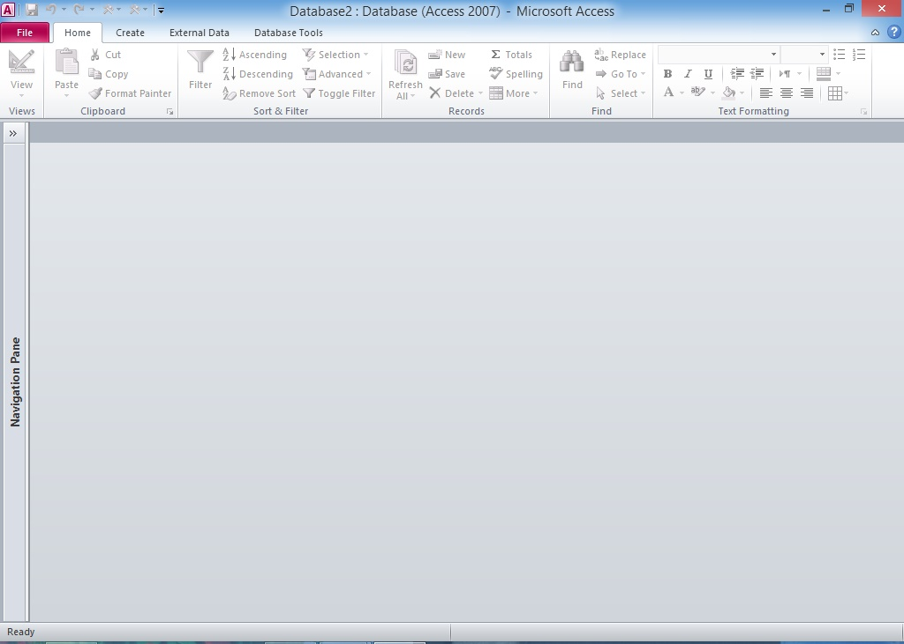
Ms-Access Windows

Chapter No. 03
Data Types in MS Access
3.1 Data Type
It is used to describe the types of data, range of data format of data of any specific fields. The most commonly data types are;
3.2 Text:-
This data type is used to store Alfa numeric data. It can store up to 255 characters.
3.3 Memo:-
When we want to save lengthy text, we can use memo we memo. We can store up to 64000 characters.
3.4 Number:-
To store Number we can use number data type.
3.5 Date and Time:-
This data type is used to store date and time.
3.6 Currency:-
To save currency we use currency data type.
3.7 Auto Number:-
This data type is used to store unique sequential or random number automatically when a new record is entered.
3.8:- Yes / No:-
This data type is used true / false, on / off.

3.9 Hyperlink:-
This data type is used to store links to other files, document or web pages in a field.
3.10 Attachment:-
This data type is used to store attachments.
3.11 OLE object:-
This data type is used to store picture, charts etc. OLE stands for Object linking and Embedding. Such as a spread sheet created in Excel or a picture file.
3.12 Lookup Wizard
This data type is used to consist a series of dialog boxes that ask you design and contents questions relation to the type of presentation you wish to create.

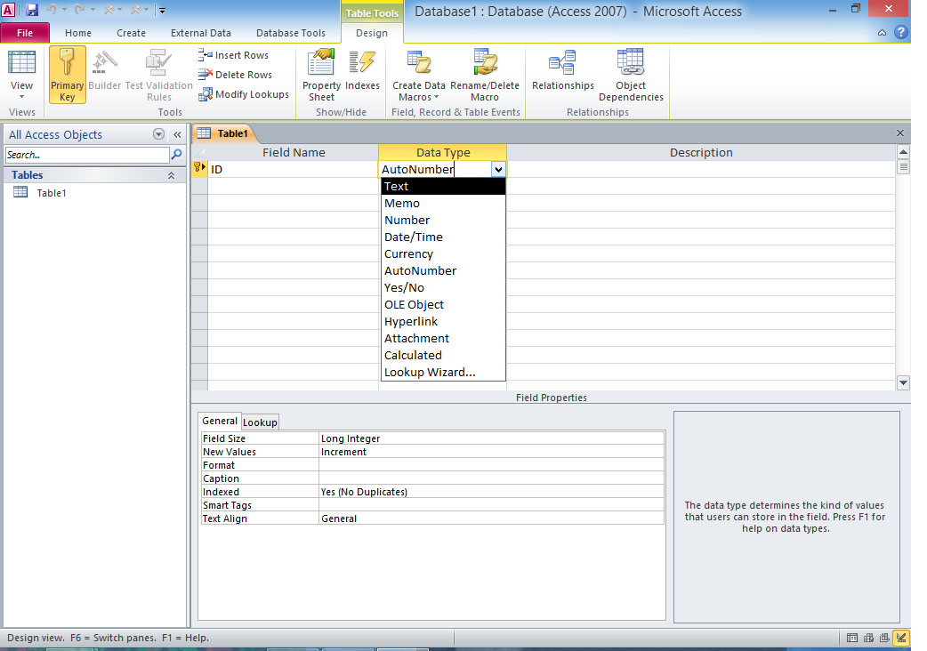
Data Type Window
Chapter No. 4
Tables in the Project
4.1 Design View
The table view that is used to design the structure of a table is called design view. It is used to specify name, data types and description of fields. Primary key is also specified in this view. The structure of an existing table can also be changed in design view.
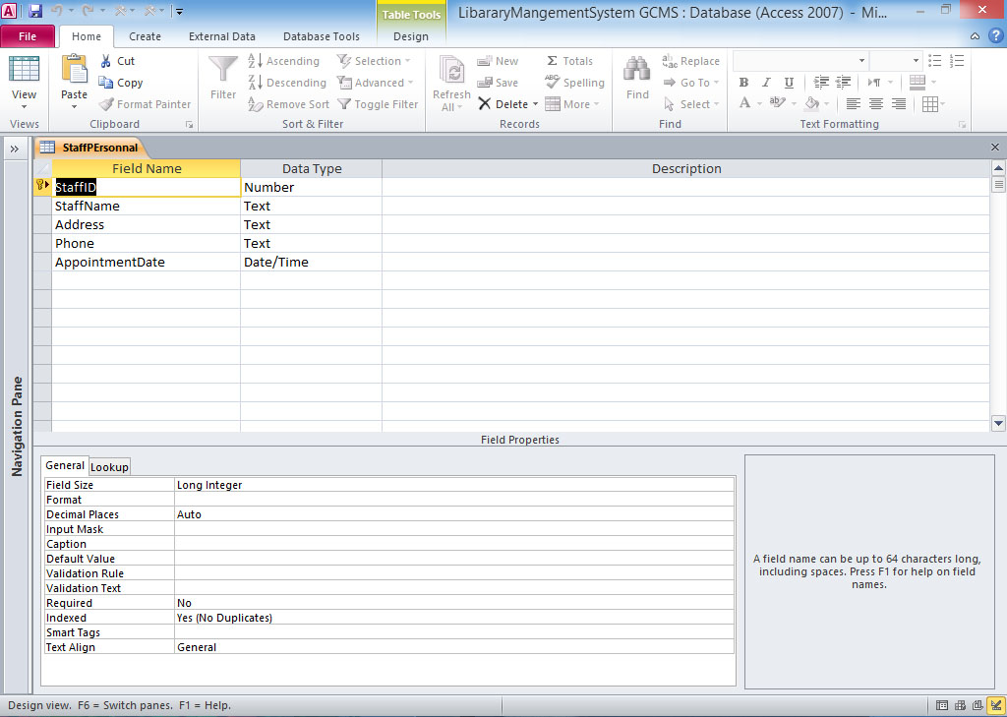
Design View
4.2 Datasheet view
The table view that is used to enter, delete or modify data in a table is called datasheet view. The table in this view is displayed in rows and columns. The name of each field is displayed at the top of the column as header. Each row contains a complete record. The table or query is opened in datasheet view to perform different operations on data in the table.
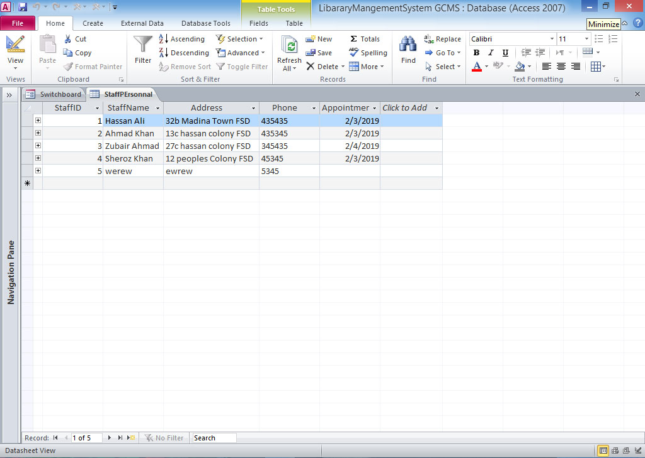
Datasheet View
4.3 How to create a table in design view
STEPS
- Open database.
- Click on create tape
- Click on table design from table group
- Type the name of first fields
- Select data type
- Select / click on second row and enter second field. Then select data types repeat the above to enter all fields in the table
- Save table
4.4 Tables in Library Management System (LMS)
A table is a collection of data. Tables organize data into columns (called fields) and rows (called records). It is used to create, modify, and manipulate tables. The tables are used to store data in the database.
4.4.1 Staff Personal:-
This table store information about each staff member making as an employ in the library all the members are allowed in issue books.
Fields in the tables: - Staff Personal (Staff ID, Staff name, Address, phone, appointment date)
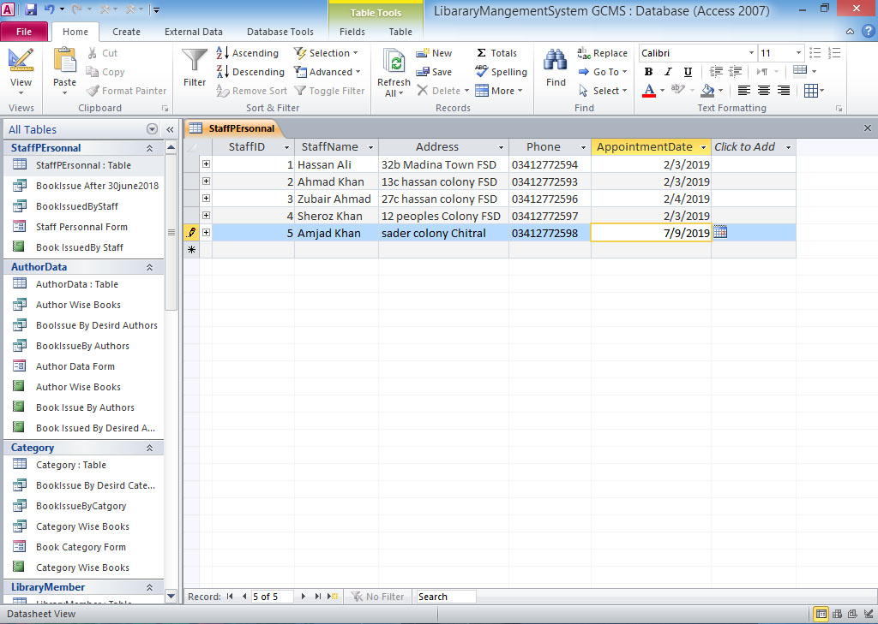
4.4.2 Author data:-
This table store information about the authors of the books.
Fields in the table: - Author data (Author ID, Author Name, Country, life status, Monthly Income)
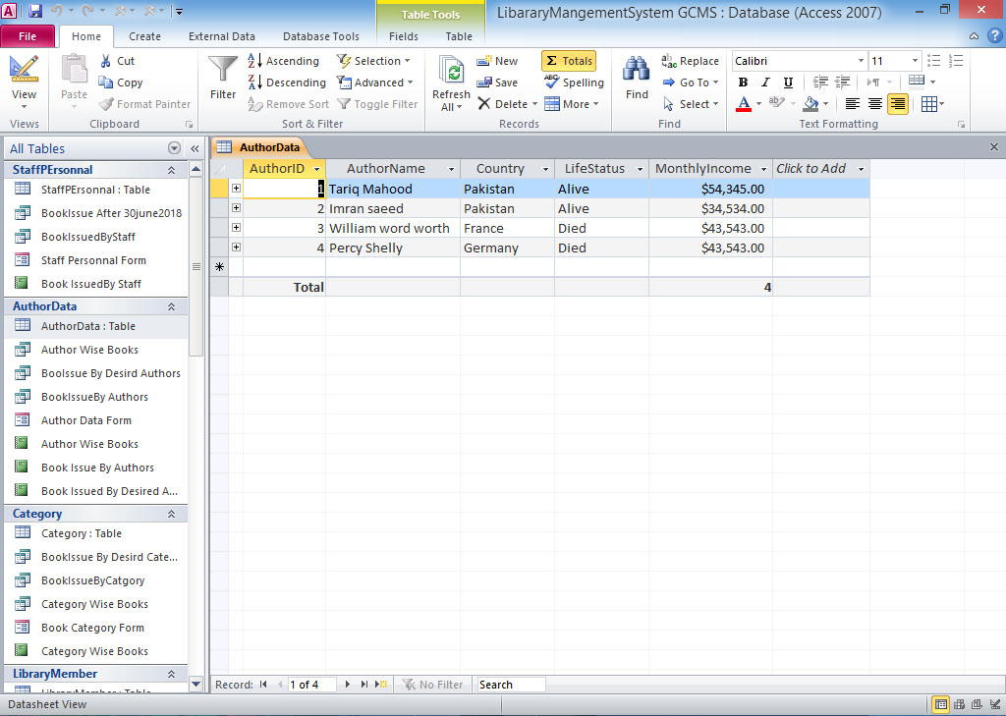
4.4.3 Books catalog:-
This table store information about each category of books.
Fields in the table: - Book Catalog (Category ID, Category Name)
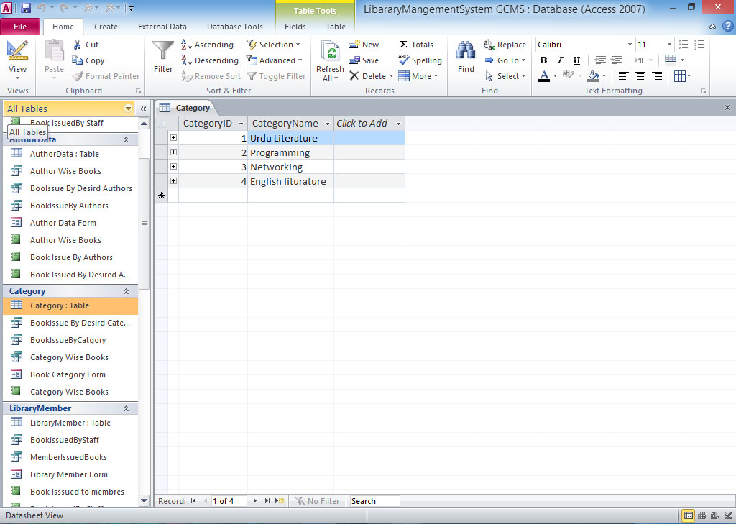
4.4.4 Library Members:-
This table store information about the registered member
Fields in the table: - Library members (Member ID, Member Name, Membership date, Address, Phone)
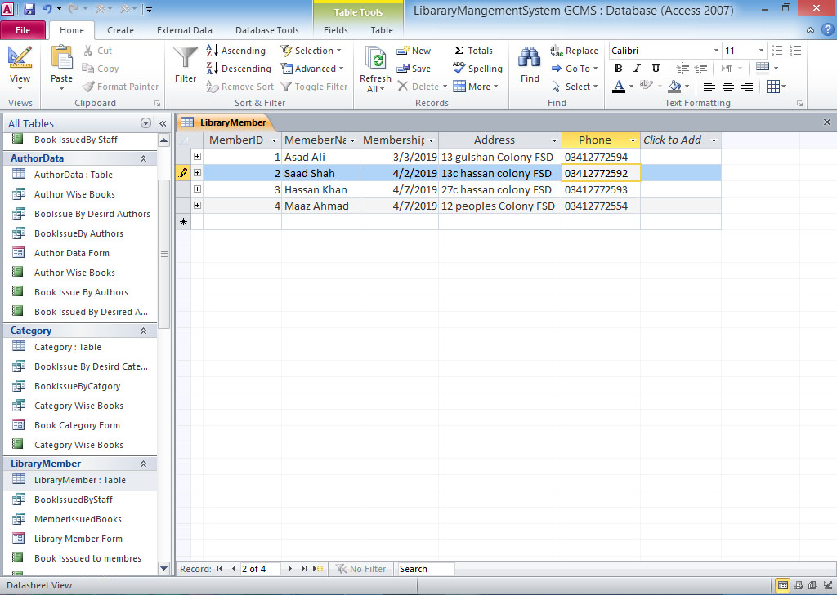
4.4.5 Book Collection:-
This table store basic information about the books present in the library.
Fields in the table: -Book Collection (Book ID, Book Name, Author ID, Category ID, Pages, Purchase Prices)
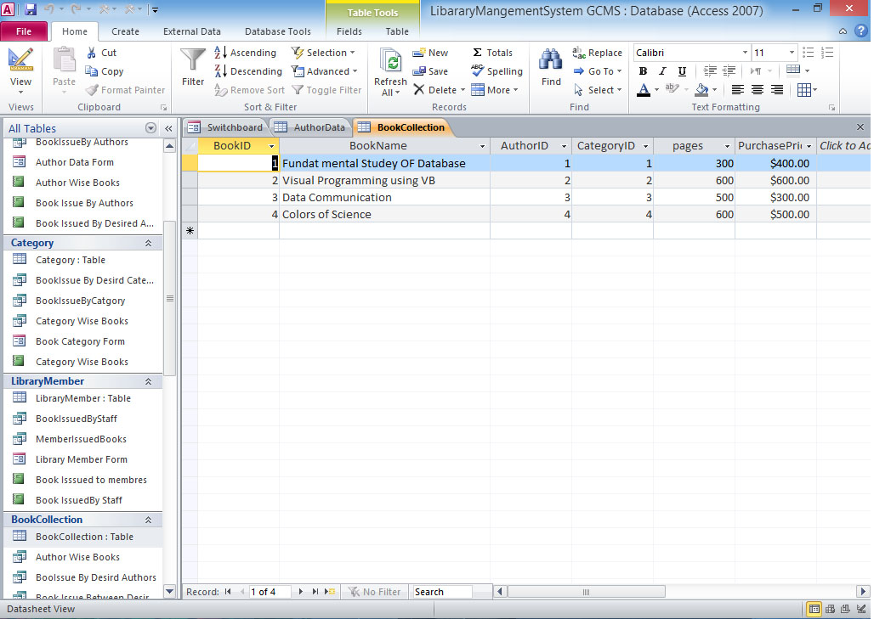
4.4.6 Book Issue Table:-
This table store information about issued books.
Fields in the table:- Book Issue Table ( Issue No, Book ID, Member ID, Staff ID, Issue date, Return Date, Fine)
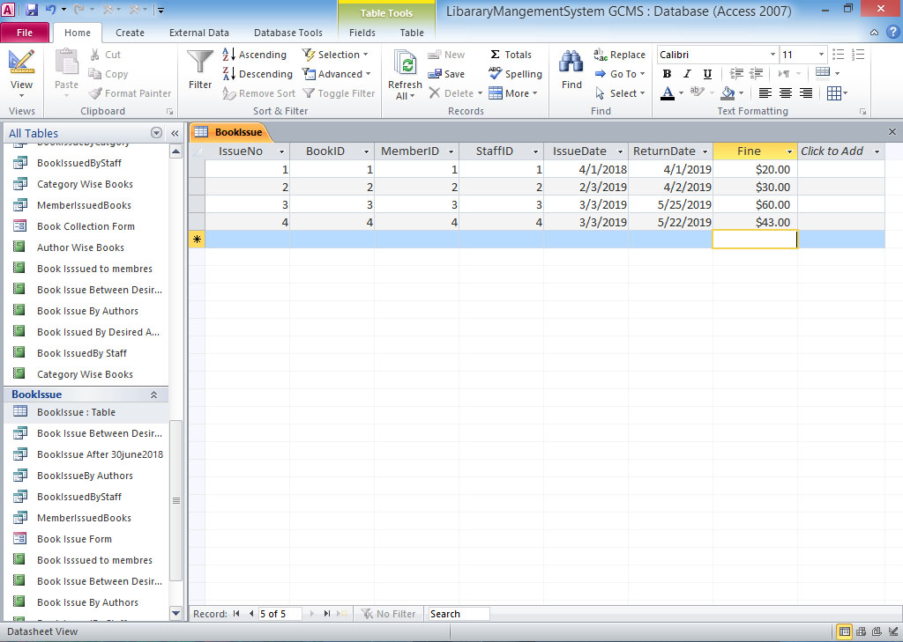


Chapter No. 05
FORMs in the Project
5.1 Form
A window that consists of visual components is called form. Forms are used to interact with databases through graphical user interface. A form is constructed from a collection of individual design elements. These elements are called controls or control objects. The common elements include buttons, check boxes, list boxes and radio buttons etc.
5.2 Uses of Form
Form is used to manipulate databases easily. It can be used to:
- Add data in the database
- Modify data in the database
- Delete data from the database
- Retrieve and view data from the database
- Search the required data from the database
5.3 Advantages of Form
Some advantages of using forms are as follows.
- Easier to Use
Form can be used by the user very easily. It contains simple graphical components that simplify the process of data manipulation.
- User-Friendly
Forms contain graphical components that are user-friendly. The users can use these forms by simply clicking different with mouse.
- No Technical Knowledge Required
A user can use manipulate database without any technical knowledge of databases. The visual components enable the user to interact with the database without writing technical statements.
- Time Saving
In some situations, forms require less time to enter data in tables. Access provides master-details form that is used to entered many records at one time.
- Flexibility
MS Access provides different types of form. These forms can display data in different styles.
5.4 Procedure for creating form in design View.
The following procedure is used to create a form in Design views.
- Click new button on the form database windows.
- Select Design View and choose table or query to which the form will be associated.
- Select View > Toolbox from menu bar to view the floating toolbar with additional options.
- Add controls to form by clicking and dragging field names from Field List floating window.MS Access creates a text box for the value and label for the field name.

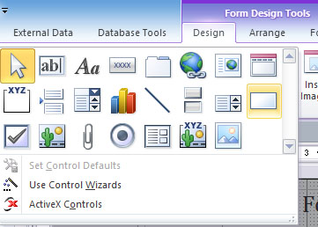
Form Design Tools
5.5:- Forms in Library Management System (LMS)
Form: A Form is a screen or window that contains numerous fields or spaces to enter data. A form is more user friendly than generating queries to create tables and insert data into the fields.
5.5.1 Staff Form:
This form allows inputting and modifying data of staff members working an employee in the library.
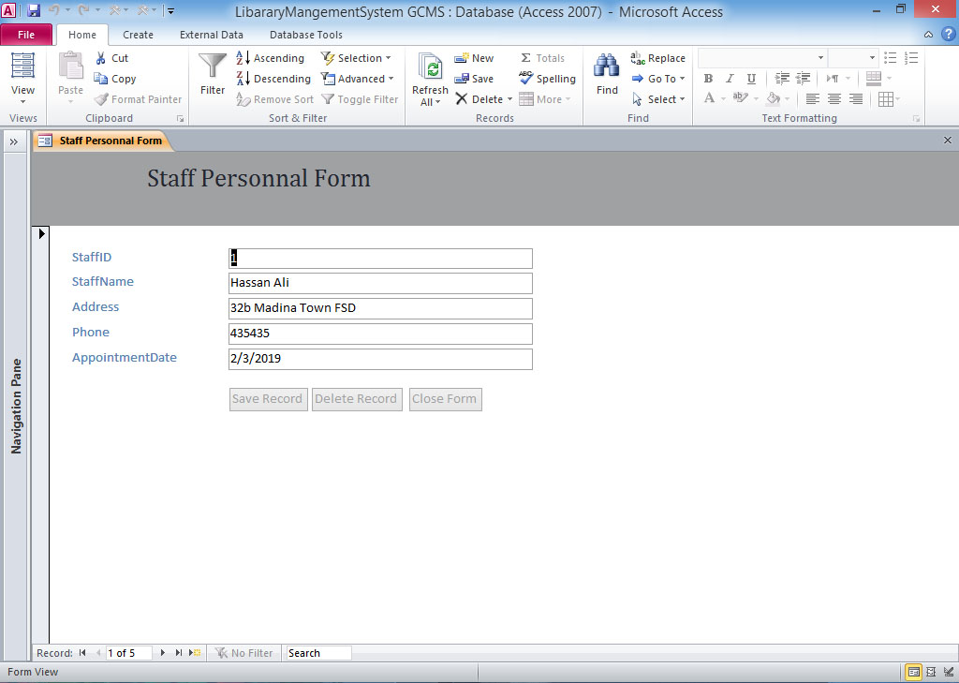
5.5.2 Author Form:
This form allows inputting and modifying data about the authors of the books.
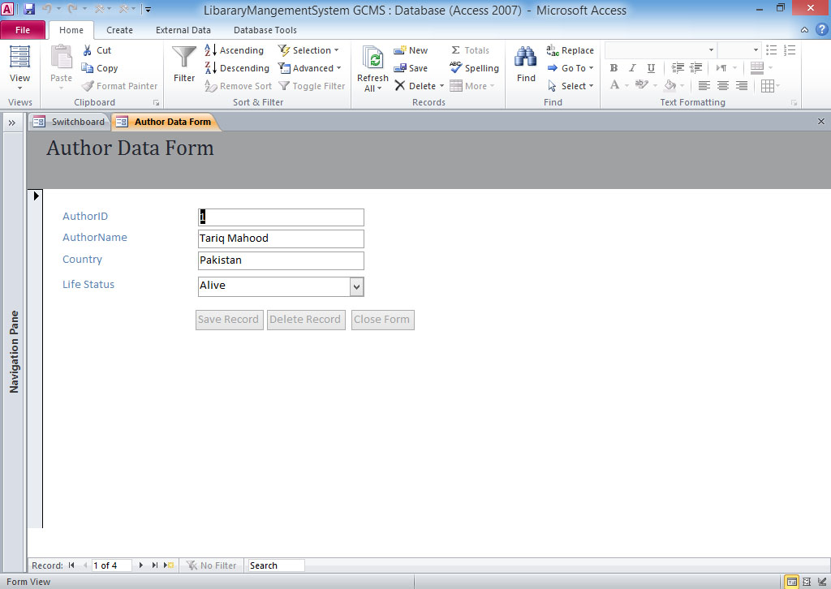

5.5.3 Book Catalog Form:
This form allows inputting and modifying data about the categories of books.
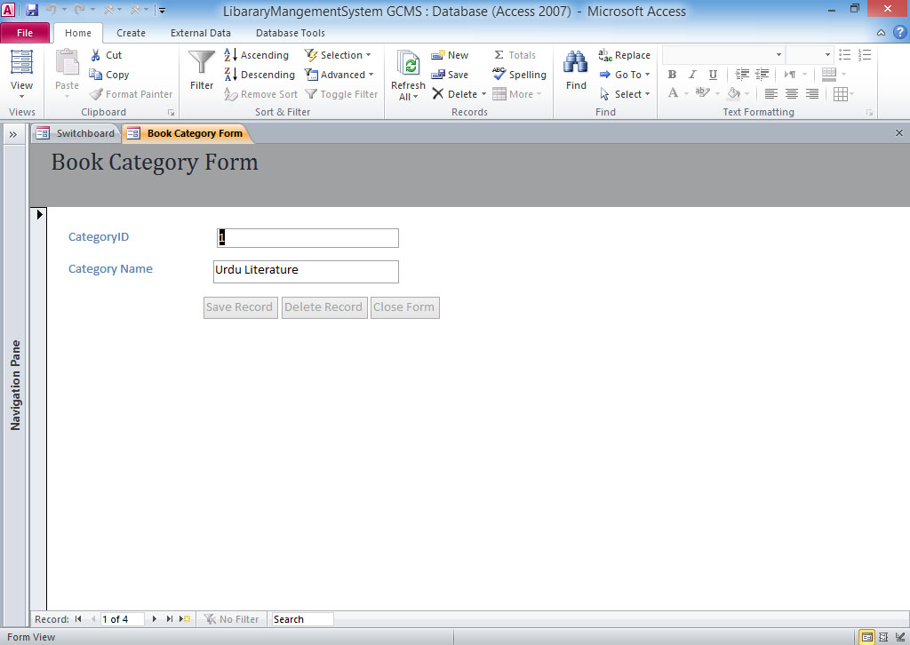

5.5.4 Library Member Form:
This form allows inputting and modifying data about the registered member of library.
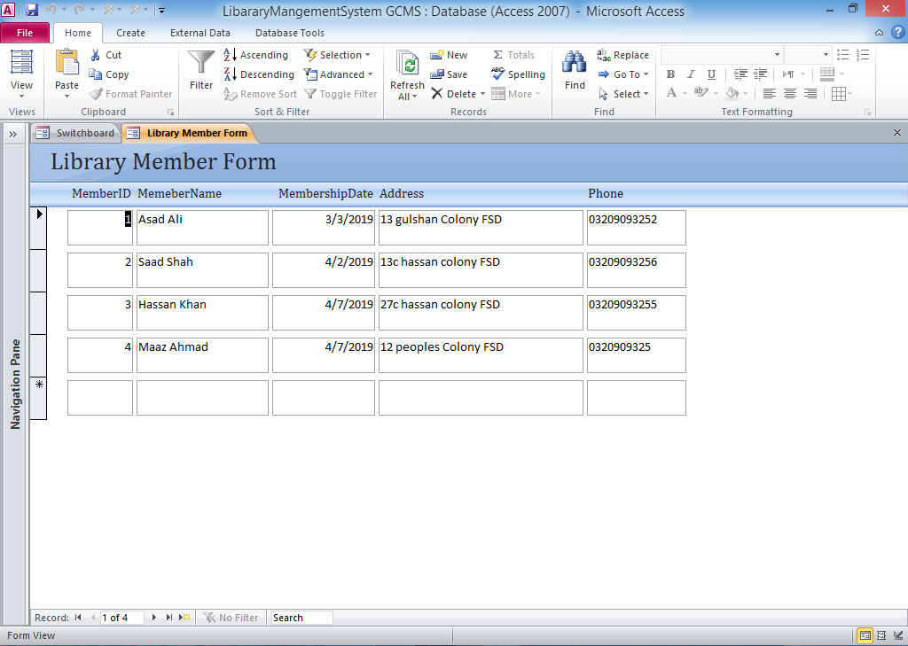

5.5.5 Book Collection Form:
This form allows inputting and modifying data about the library books.
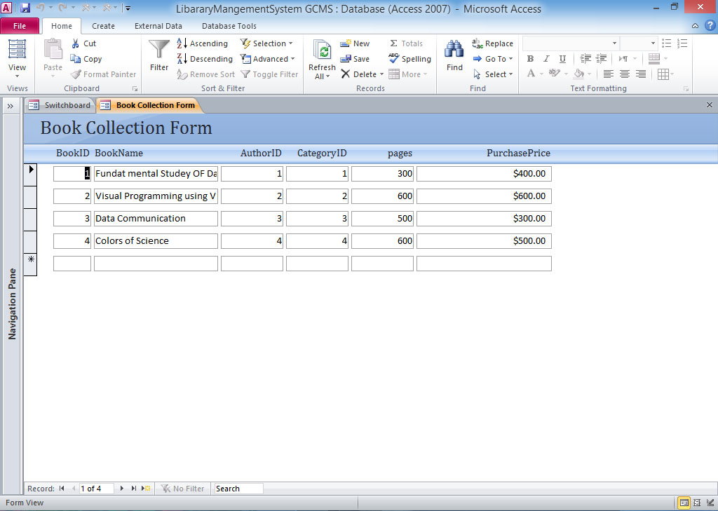
5.5.6 Book Issue Form:
This form allows inputting and modifying data about issuance of books to different members.
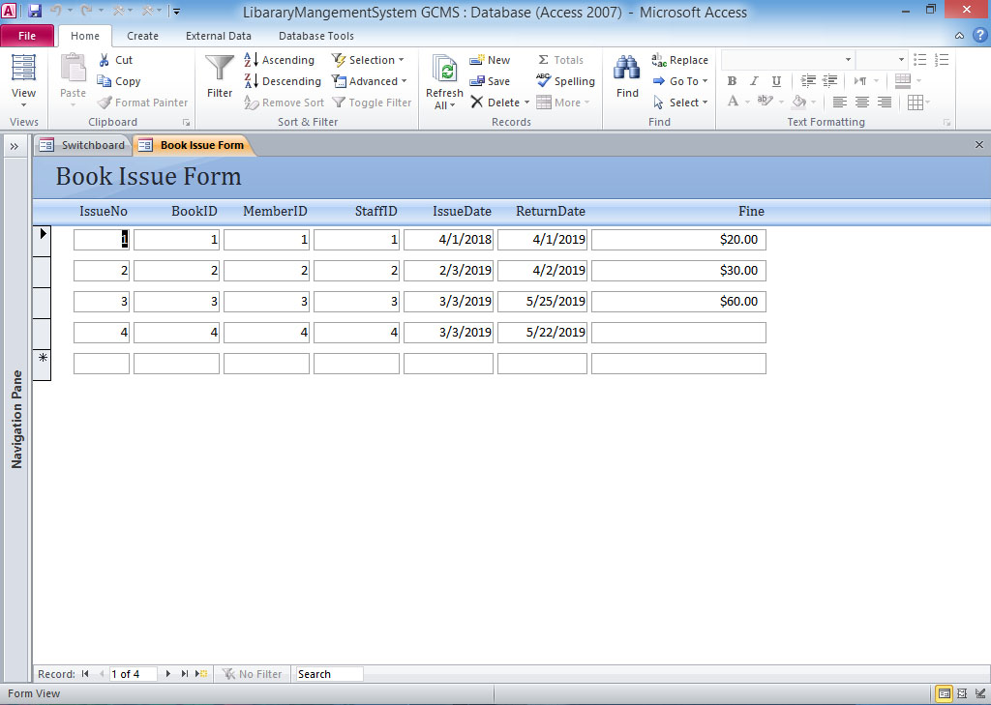

5.5.7 Option Windows:
This form is designed to provide quick access to each object in the database. It contains buttons, query, form, reports in the database.
Chapter No. 06
Database Terminologies and ERD
6.1 Entity
An entity is a person, place, thing, or event for which data is collected and maintained. Thus entity has a noun name. Some examples of each of these kinds of entities follow:
Person: STUDENT, EMPLOYEE, PATIENT
Place: STORE, WAREHOUSE, STATE
Object: MACHINE, BUILDING, AUTOMOBILE
Event: SALE, REGISTRATION, ADDMISSION
Concept: ACCOUNT, COURSE
Entities are written in Upper case letters. Entity is denoted by a rectangle symbol in ERD.

6.2 Entity Type
The collection of entities having similar attributes is called Entity type. It is the basic elements of entity relationship diagram. It can represent physical object such as people and place as well as events such as payment. Entity type is denoted by rectangle, the properties of entity type are called attributes and each attribute has a data type.
6.3 Attribute
A property or characteristic of an entity or relationship type that is of interest to the organization is called attribute. Following are some typical entity types and their associated attributes.
STUDENT Class_Roll_No, Student Name, Address, Phon_Number AUTOMOBILE Vehicle_ID, Color, Weight, Horsepower
EMPLOYEE Employee ID, Employee Name, Skill

6.4 Relationship
A relationship is an association, linkage, or connection between the entities. The relationship may be between different entities or between an entity and itself.
Relationship represents an association between two or more entities. An example of a relationship would be:
• TEACHER teaches the STUDENT
• STUDENT studies COURSE

6.4.1 Creating Relationship
The procedure for creating relationship between tables is as follows:
- Start Microsoft MS Access.
- Select File > New from menu. A dialog box will appear.
- Choose Data base option and click OK.
- Enter the name of new database and click create button. A new database will be created and the main window will appear.
- Double click on Create table in Design view option.
- Create a table
- Set the fields and save the table.
- Create the second tables with the following fields.
- Select Tools > Relationships.
- Select table and click Add
- Click close button to close dialog box.

6.4.2 Relationship in Library Management System (LMS)

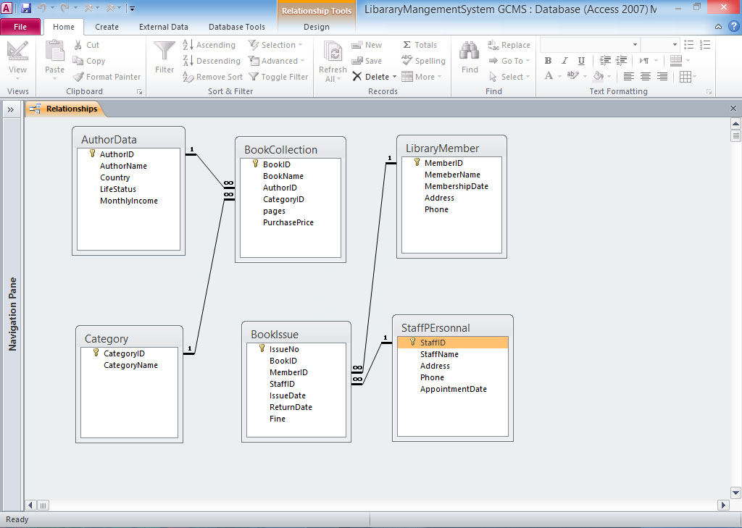
6.4.3 Entities for the Proposed System
The Entities and its attributes for the proposed system are as below:
STUDENT Class_Roll_No, Name, F/Name, Address, Technology etc.
FEE Addmison Fee, Monthly_Tution_Fee, Security_Fee, Board_Exam_Fee etc.
RESULT Total_Marks, Obtained_Marks, Percentage, Pass-fail, Remarks
TEACHER Name, F/Name, Address, Cell_No, Subjects etc.
6.5 E-R model
The entity-relationship (E-R) data model perceives the real world as consisting of basic objects, called entities, and relationships among these objects. It was developed to facilitate database design by allowing specification of an enterprise schema, which represents the overall logical structure of a database. The E-R data model is one of several semantic data models; the semantic aspect of the model lies in its representation of the meaning of the data. The E-R model is very useful in mapping the meanings and interactions of real-world enterprises onto a conceptual schema. Because of this usefulness, many database-design tools draw on concepts from the E-R model.

6.5.1 Symbol Used in ERD
This Rectangle symbol represents the entity.
This diamond symbol represents a relationship between the entities.
This ellipse symbol represents an attribute.

6.5.2 Relationship Types
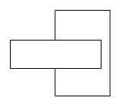This symbol represents a unary relationship.
This symbol represents a binary relationship.

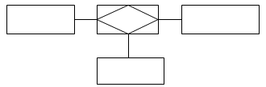 This symbol represents ternary relationship.
6.5.3 Modality
Number of instances of an entity that can be associated with each instance of another entity is called modality.
The following symbols are used to show the modality.
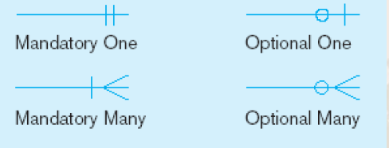

6.6 Advantages of ER Model
Some of the important advantages of ER model are as follows:
- Visual representation: The foremost and most important ERD benefit is that it provides a visual representation of the design. It is normally a crucial to have an ER model for an effective database design.
- Effective communication: An ERD clearly communicates the key entities in a certain database and their relationship with each other. This allows a designer to effectively communicate what exactly the database will be like. Thus the designer is able to satisfy the user and other stack holders about the database design.
- Simple to understand: ERD is easy to understand and simple to create. In effect, this simple design can be used to be shown to the representatives for approval.

6.7 ERD for the Proposed System

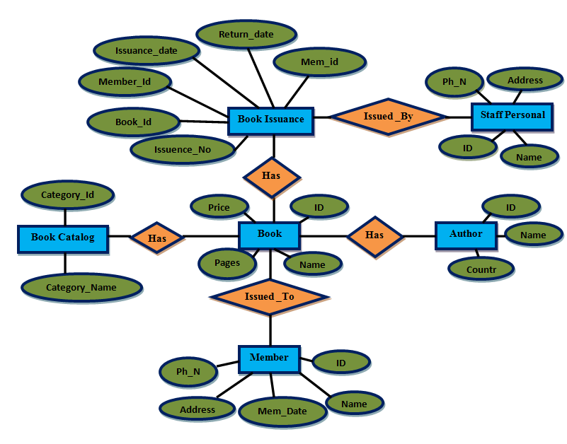
ERD of the Proposed System

Chapter No. 07
Query in the Project
7.1 Query
A query is a statement that extracts specific information from database. Query is a request for data or information it is a request to database to retrieve update delete record from a database. A query is created by specifying fields to display from a table or another query. It can also specify criteria on one or more fields for extracting data. The queries can select records from one or more tables in a database. The data cart be viewed, analyzed and sorted on a common datasheet.
7.2 Uses of Query
A Query can be used for the following purposes:
- Extract records according to the specified criteria.
- Choose the fields to display in the result.
- Sort the record specific order
- Calculate fields and summarize data
7.3 Advantages of Query
Some important advantages of using query are as follows:
- Flexibility
Query is a flexible way to manipulate data in databases. It provides different facilities to add, deleted, modify and search data easily.
- Joining
Query can be executed against multiple tables. If the tables are related with one another the query can join these tables for extracting data.

- Ease of Use
Queries are very easy to use. The user can execute queries easily to perform different operations on the databases
7.4 Procedure for creating Query
The procedure for creating simple query is as follows:
- Open the data base.
- Click on Queries button in main database window.
- Double click Create query in design view.
- Select Query will appear. It will contain another dialog box.
- Select the table for extracting data.
- Click Add button
- Click Close button.
- Select any field from field list box to include it in the query in the bottom of window.
- Add all other fields that are to be included in the query.
- Select the sorting order from sort list box.
- Give any condition in criteria field if required.
- Click on save button on toolbar to save the query
- Type the name of query
- Click Ok. The query will be saved.
- Select Run from Query, menu to execute the query and view its result.
7.5 Procedure for executing a saved query.
A query that has been saved on the disk can be executed later. The following procedure is used to execute a saved query.
- Open database that contain the saved query.
- Click Queries button in the object list. The names of all saved queries will appear.
- Double click any query name. It will be executed and result of the queries will appear.

7.6 Queries in Library Management System (LMS)
Queries are the primary mechanism for retrieving information from a database and consist of questions presented to the database in a predefined format.
7.6.1 Author wise book:
This query provides information all about the available books. According to authors add author data table and book collection table fields in the query.
Fields in the query: Author name from author data, book name, pages, purchase price from book collection table.
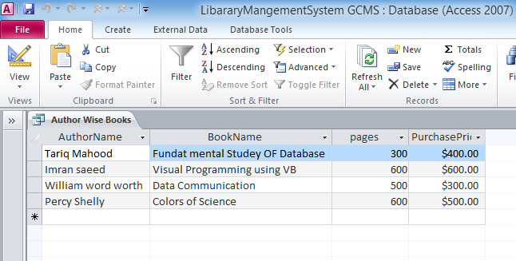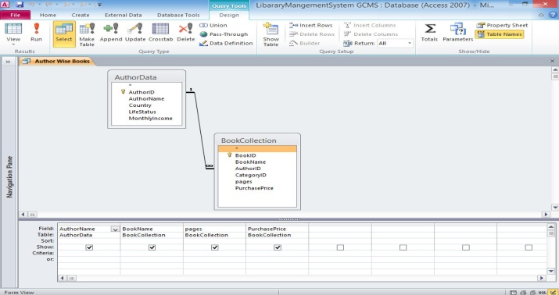
7.6.2 Category wise Book: This query is provides information about all the available books according to category. Add book catalog table and book collection table in the query table.
Fields in the query: Category name, book catalog, Book name, pages, purchase price, from book collection table.
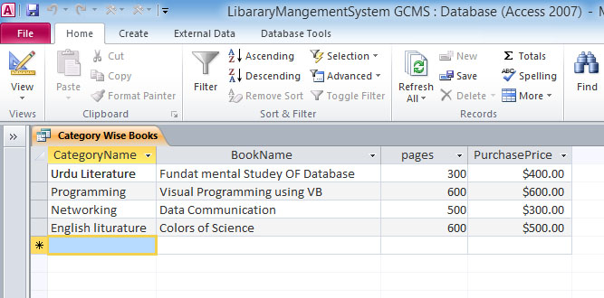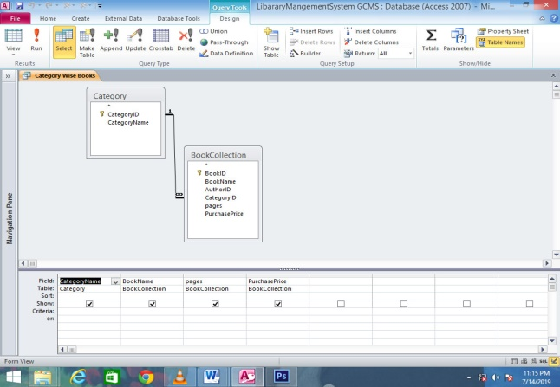

7.6.3 Book Issued by Author: This query provides information about the issue book according to their authors. Add three tables in the query window.
(i) Book Issue table (ii) Book Collection table (iii) Author data table
Fields in the query: Issue number from Book issue table, Book name from book issue table, Author name from Author data table.
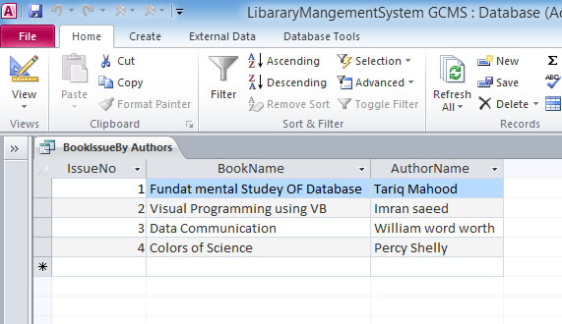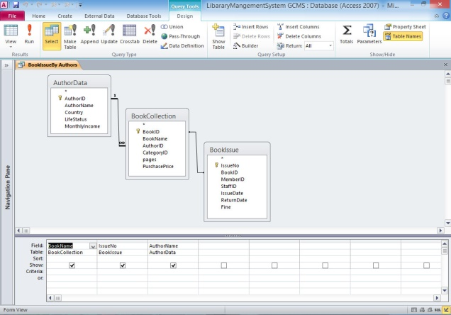
7.6.4 Member Issue Book: This query provides information about the members and book issued to them. Add three tables in the query window.
(i) Library Member table (ii) Book Collection table (iii) Book Issue table
Fields in the query: Member Name, Membership date from library member tables. Book name from book collection table. Issue date, return date from book issue table.
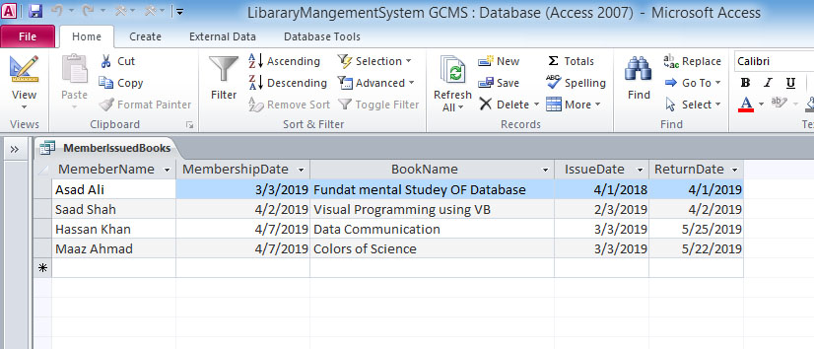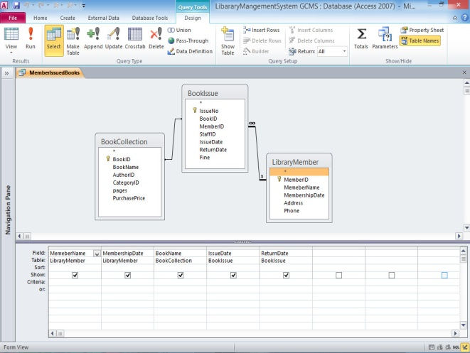

7.6.5: Book Issued by staff: This query provides information about the staff and the book which was issued. Add four tables.
(i) Staff personal table (ii) Book issue table (iii) Book collection table (iv) library member table
Fields in the query: Staff name from staff personal tables. Book name from book collection table, issued from library member table, issue date, return date from book issue table.
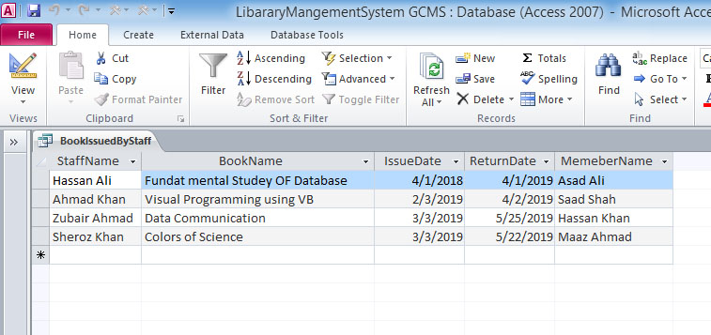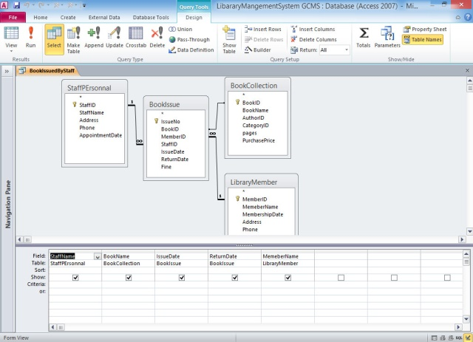
7.6.6 Book Issue by desired author: This query is parameter query that prompts user to enter author name it than display book according to that author. Add two tables.
(i) Author data table (ii) Book collection table
Fields in the query: Author name from author data tables, Book name, pages, purchase price from book collection table.
Parameter in the query: write [Enter author name] in a criteria box below author name.
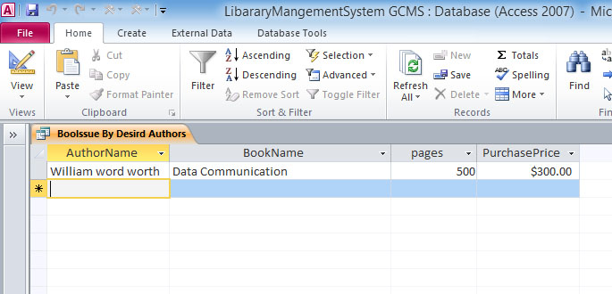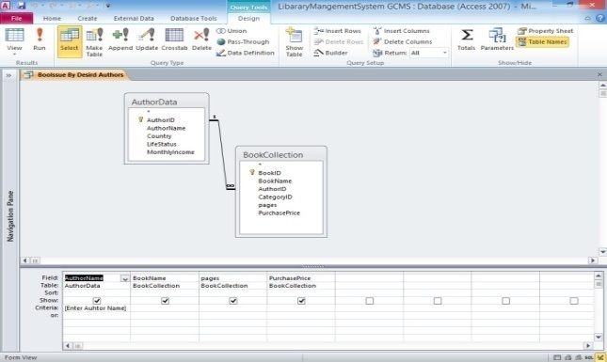

7.6.7 Book Issue after 30th June 2018: This query provides information about all the books that are issued after 30th June 2018. Add three tables.
(i) Book issue (ii) Book collection table (iii) staff personal table
Fields in the query: Book name from book collection table, staff name from staff personal table, issue date from book issue table.
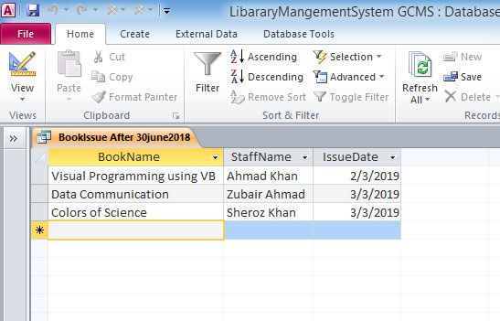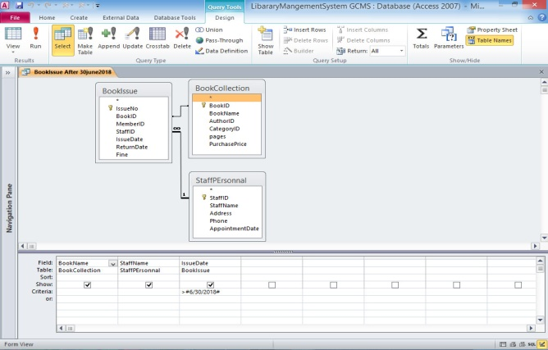
7.6.8 Book issue between desired periods: This is also a parameter query that prompts user to enter starting date and end date .Add two tables.
(i) Book issue table (ii) book collection table
Fields in the query: Issue Number from book issue table, book name from book collection table, issue date from book issue table
Parameter in the query: Write between [enter start date] and [Enter end date] in criteria box below book issue date.
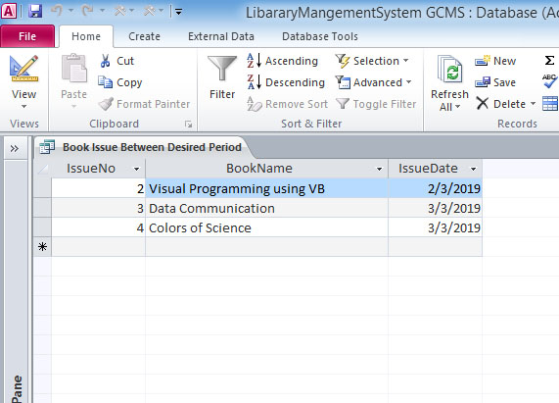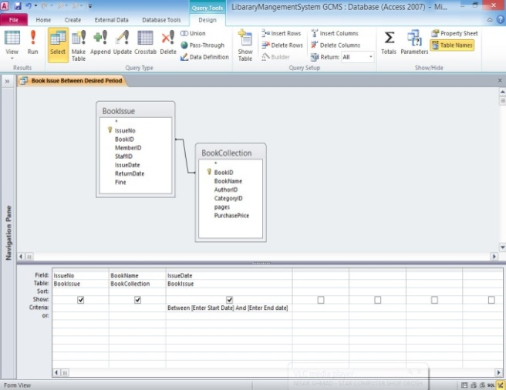
Chapter No. 08
Reports in the Project
8.1 Reports: - Reports are a great way organize and present data from Access database. Reports enable to format data in an attractive and informative layout for printing or viewing on screen. Reports are often used to present a big- picture overview, highlighting main facts and trends. The data in a preview or in a printed report is static. Reports merely present the data; they do not alter the underlying data in the tables. Each time a report is opened, Access displays the most recent data.
8.2 Creating a Report:-
Reports are created from one or more tables or queries. To use several tables, we would first create a query to retrieve data from those tables.
There are three basic ways to create a report: with a single mouse click, with the report wizard, or in design view.
To create a report with a single click,
- Open the table or query upon which we want to base the report.
- On the Create tab, click Report.
- The report is created and displays all the fields from the underlying table or query. The Report tool may not create the final, polished product that we ultimately want, but it is quite useful as a means to quickly look at the underlying data. You can then save the report and modify it in layout view or design view so that it better serves your purposes.
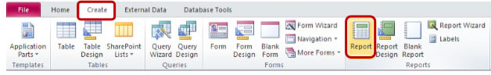

8.3 Creating a Report using Wizard:-
To create a report using the wizard,
- On the create tab, click Report Wizard.
- Follow the screen prompts.
- Additional customization can be done in Design or Layout view.
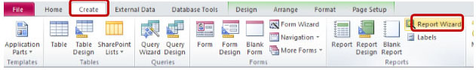
8.4 Creating a Report using Design View:-
- On the Create tab, click Report Design.
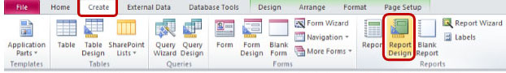
- Click on the Add Existing Fields Button on the Design tab, to see a list of tables/ fields.
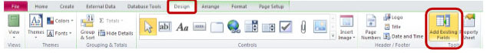
- Drag or double- click fields to add them to the grid, as desired.
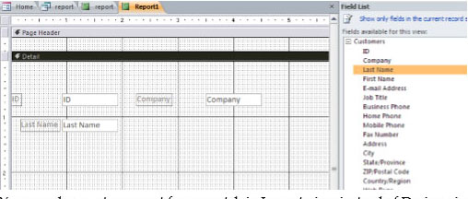
- You can also create a report from scratch in Layout view instead of Design view. From the Create tab, click Blank report.
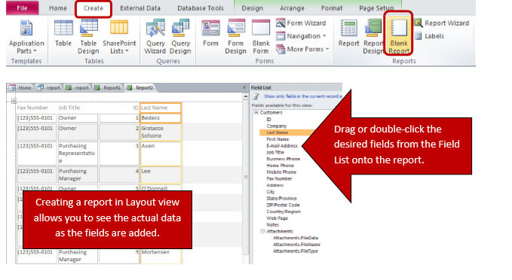
8.5 Auto Format in Report:-
To save time, we can apply a present format- known as an Auto Format ---- to all or part of your report. You can select the size and appearance of a report’s sections and controls, as well as adjust background colors, borders, and text styles.
- Select the control and use the buttons available on the Design tab in the Themes group.
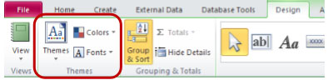
- Use the Auto Format button on the Arrange tab to apply a present format.
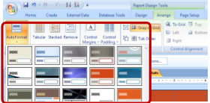

8.6 The Advantages of Using MS Access Report:-
Microsoft Access is a relational database management system for the Microsoft Office package. A user can create databases and present queried data in easy- to – design reports. These reports contain several benefits over report functions in other programs.
8.6.1 Ease of Use:-
To design a report in Microsoft Access, all a user has to do is point and click. By selecting data for the report and choosing among many options of style features, the user can create a fully functional report.
8.6.2 Data Presentation:-
Reports can be created with data grouped together by category. This contains subtotals, counts and other powerful formulas that save time and provide greater analysis.
8.6.3 Updating Reports:-
If the user updates information in the database, a report can be recreated to contain the new information. The prior version will remain consistent, allowing the user to compare versions.
8.7 Uses of reports in MS Access:-
The followings are the uses of reports in MS Access
- Reports are a great way or organize and present data from your Access database.
- Reports enable you to format your data in an attractive and informative layout for printing or viewing on screen.
- Reports are often used to present a big- picture overview, highlighting main facts and trends.
- A user can create databases and present queried data in easy- to- design Reports.
- Display or distribute a summary of data.
- Archive snapshots of the data.
- Provide details about individual records.
- Create labels.

8.8 Reports in Library Management System (LMS):-
Library Management System database contain the following reports.
8.8.1 Author wise Books:-
This report provides information about all the available books according to authors.
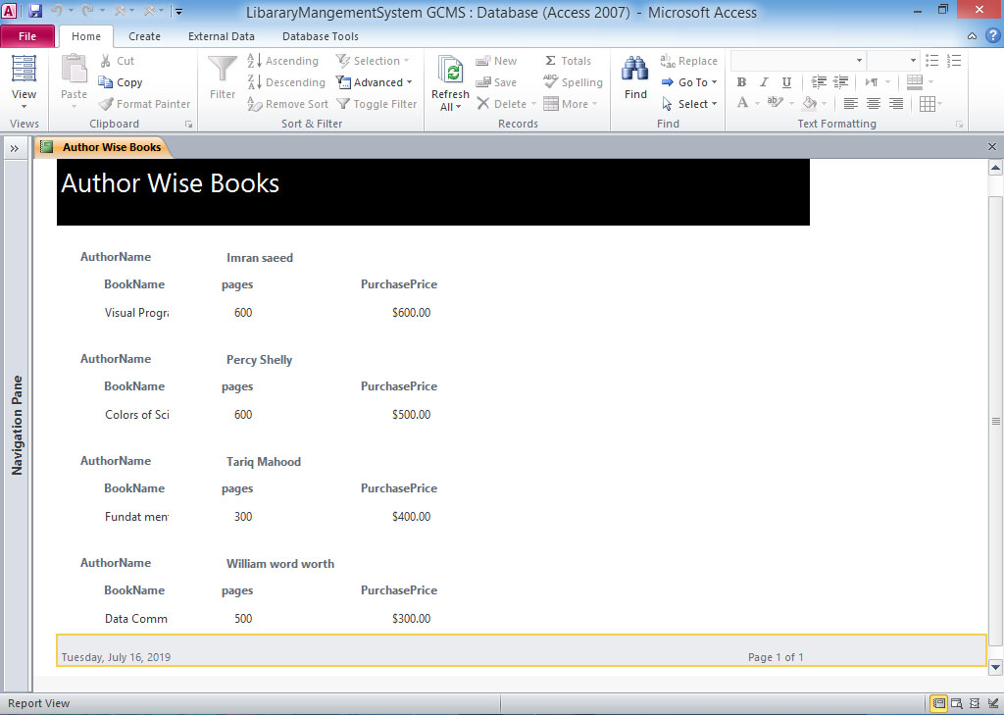
8.8.2 Category wise Books:-
This report provides information about all the available books according to category.
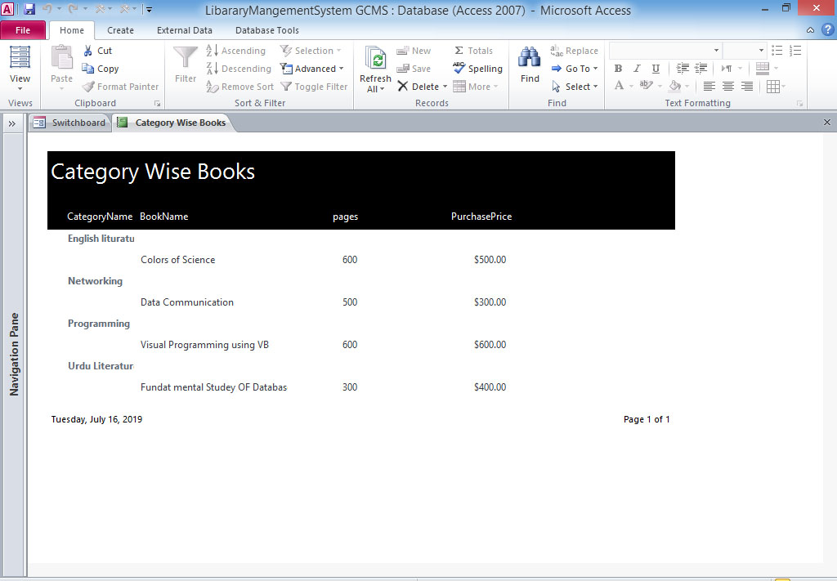
8.8.3 Book Issued by Author:-
This report provides information about the issued books according to their Authors.
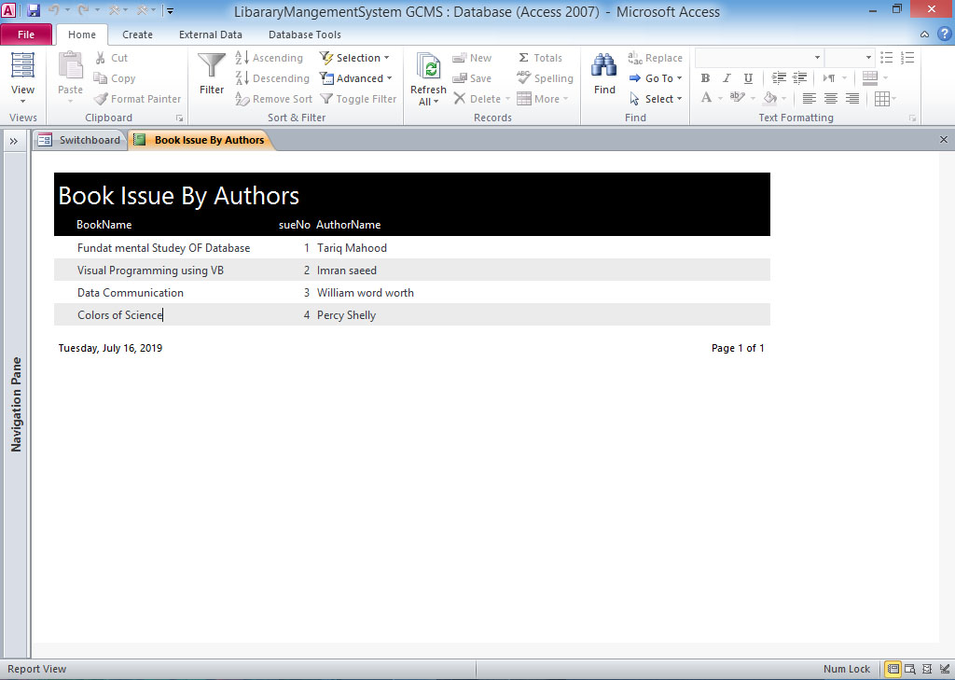
8.8.4 Books Issued to Members:-
This report provides or previewed information about the member.
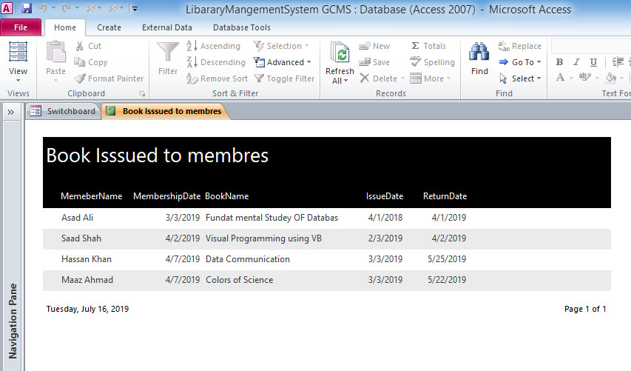
8.8.5 Books Issued by desired Author:-
This report is a parameter query and it promotes users to enter author name it than generate a reports of book of author enter by the user.
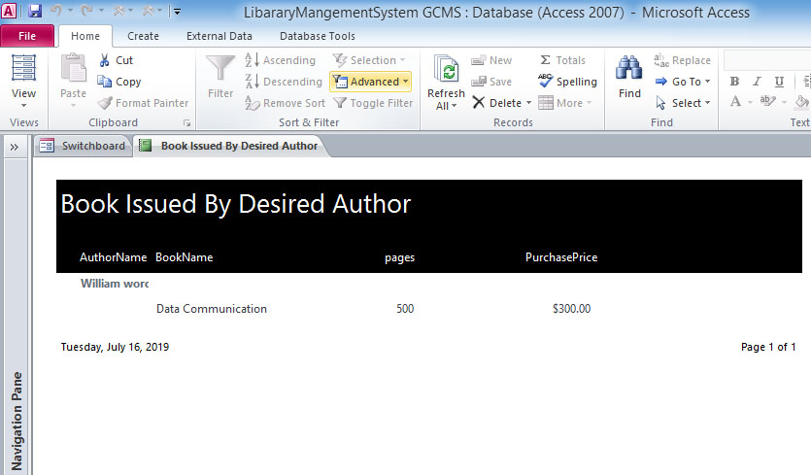
8.8.6Book Issued between desired period:-
This report is a parameter query and it promotes the user to enter starting data and ending date it then generate a report of books issued.
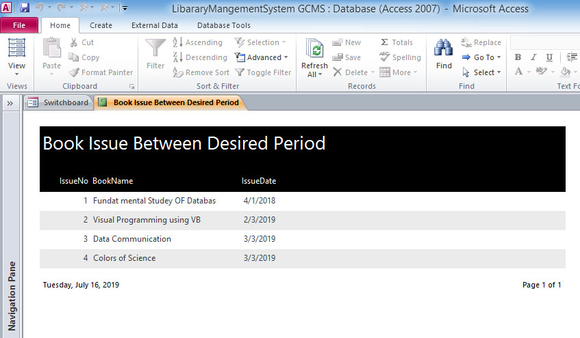
8.8.7 Books Issued by staff:-
This report provides information about all the books issued by the staff.
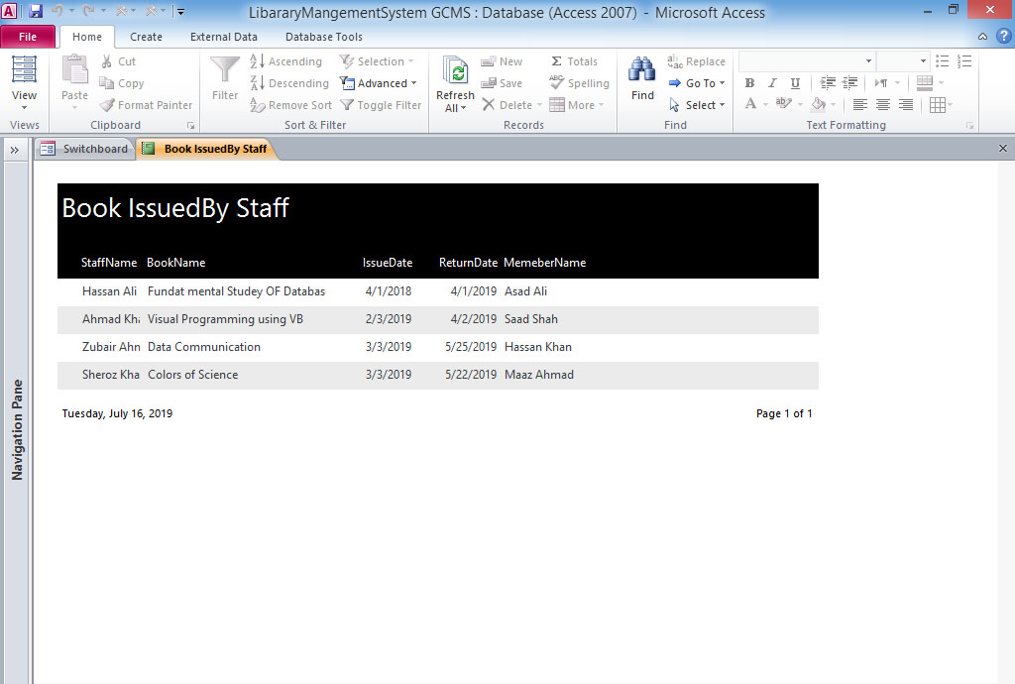
Chapter No. 09
Switchboard in the Project
9.1 Switchboard: -A switchboard is a form that allows you to navigate around your Access database. The switchboard is made of buttons that you click. You can program these buttons to open forms, reports, queries; etc. Switchboard is made of buttons that we click. We can program these buttons to open forms, reports, queries, etc.
Microsoft provides a switchboard wizard that allows you to define the look and feel of your switchboard.
A switchboard is essentially a Microsoft Access form that allows you to facilitate navigation or perform tasks within your database application. This form is basically a customized menu that contains user- defined commands; using either buttons, labels, images or hyperlinks, that invoke actions that will automatically carry out tasks for you such as opening other forms, running queries or printing reports.
The form will be typically contain various command (buttons), which your users can then click on the carry out the pre- defined actions that you have associated with these commands.
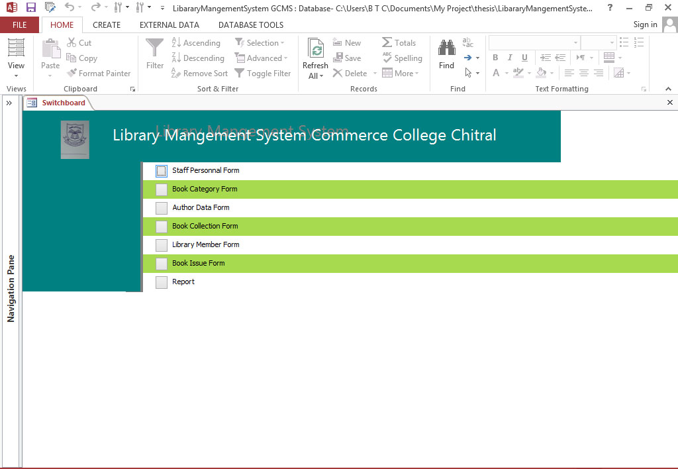
Switchboard in Library Management System (LMS)
9.2 Key Benefits of creating a switchboard in MS Access:-
Followings are the key benefits of creating a switchboard in MS Access:
- With the help of a switchboard form you can create a click based interface that can help people to access specific datasets, reports or other forms.
- In a switch board form you can include buttons which when clicked would take you to a desired location.
- Using the command box in a switchboard you can perform a desired activity.
- It is extremely easy to create a switchboard in MS Access and even after one has been created you can edit by going into the Design view.
- Switchboards are more of a necessity when you are using Access to run a line of business function.
9.3 Create a switchboard in MS Access:-
Starting in Access, the switchboard Manager isn’t available on the Ribbon so you first need to add the command to the Quick Access Toolbar. The first few steps here show you how to add this command to the Quick Access Toolbar.
- Click the down arrow on the Quick Access Toolbar and then click More Commands. Access opens the Access Options dialog box with the Quick Access Toolbar section selected.
- In the Choose Commands From combo box, select All Commands.
- Select Switchboard Manager and then click Add. Click Ok to save your changes and to close the Access Options dialog box.
- On the Quick Access Toolbar, click Switchboard Manager to open the tool. Microsoft Access asks if you’d like to create a switchboard, click Yes. This creates a Main Switchboard. You can either add all your switchboard commands to the Main Switchboard or create secondary switchboards.
- To create secondary switchboards, click New. The Create New dialog box appears.
- Type the name of the new switchboard and click OK. Microsoft Access adds the switchboard to the list in the Switchboard Pages box.
- Repeats steps 5 through 6 for each secondary switchboard you want to create, and then click Close.
9.4 Add Items to a switchboard in MS Access:-
After create switchboard, you will have to add items or menu commands that perform various tasks such as opening forms and reports in the database. The items that you add to the switchboard appear as command buttons.
- From the Switchboard Manager Dialog box, select the switchboard, and then click Edit. The Edit Switchboard Page dialog box appears.
- Click New. The Edit Switchboard item dialog box appears.
- Type the name of your command item in the Text box, and select a suitable command from the Command list.
- Click OK.
- Repeat steps 1 through 4 until you have added all the required commands to the switchboard.
9.5Edit Items in a switchboard in MS Access:-
You might have to edit items in a switchboard for several reasons such as, to change a command label or change how a command performs.
- Click Switchboard Manager on the Quick Access Toolbar.
- In the Switchboard Manager Dialog box, select the switchboard you want to edit, and then click Edit.
- Click the item on the switchboard you want to change and then do one of the following:
- To change the text of the item, the command performed by the item, or the object that is opened or run when you click the item, click Edit.
- To delete an item, click Delete.
- To move the order in which an item appears. Click Move Up or Move Down.
- When you finished editing your switchboard items, click close.
9.6 Delete a switchboard or Switchboard Items in MS Access:-
You can delete an unwanted switchboard or a switchboard item with the Switchboard Manager. However, when you delete a switchboard, you will also be deleting all the items assigned to that switchboard.
- Click Switchboard Manager on the Quick Access Toolbar.
- In the Switchboard Manager Dialog box, select the switchboard you want delete, or that contains the item you want to delete.
- To delete the Switchboard, go to step 6.
- To delete an item click Edit. The Edit Switchboard Page dialog box appears.
- Select the items you want to delete.
- Click Delete.
- Click Close.
9.7Display the main switchboard on start up in MS Access:-
- Click File>Options to open the Access Options dialog box.
- Click Current Database.
- Select Switchboard from the Display Form drop- down list.
- Click OK.
- Close the database and reopen it. The switchboard opens automatically.

References
[i] ,[i],[iii] Jeffery .A. Hoofer, M.B.P and F.R.M 2008 “Modern Database Management Eight edition ement”

[iv] Silberschatz, Korth, Sudarshan 2011 “Database System Concepts, Fourth Edition” Fourth edition
Web Resources
[v] https://mcabcaprojects.com/212-library-management-system-project-vb-sql/
[vi] http://dataalog.wordpress.com/2012/12/10/library-management-system-2/
[vii]http://enevonprojects.com/e-library-project/amp
[viii] http://www.techothenet.com/access/switchboard/
[ix] http://support.office.com/en-ie/article/create-and-user-a-swichboard-f8b3d607-8f1f-4ecf-9979-79b1565f5471
[x] http://www.datanumen.com/blogs/key-benefits-of-using-a-switchboard-in-ms-access/



